**VBA Stock Data Homework – Stephanie Omotosho**

**2016 Summary**

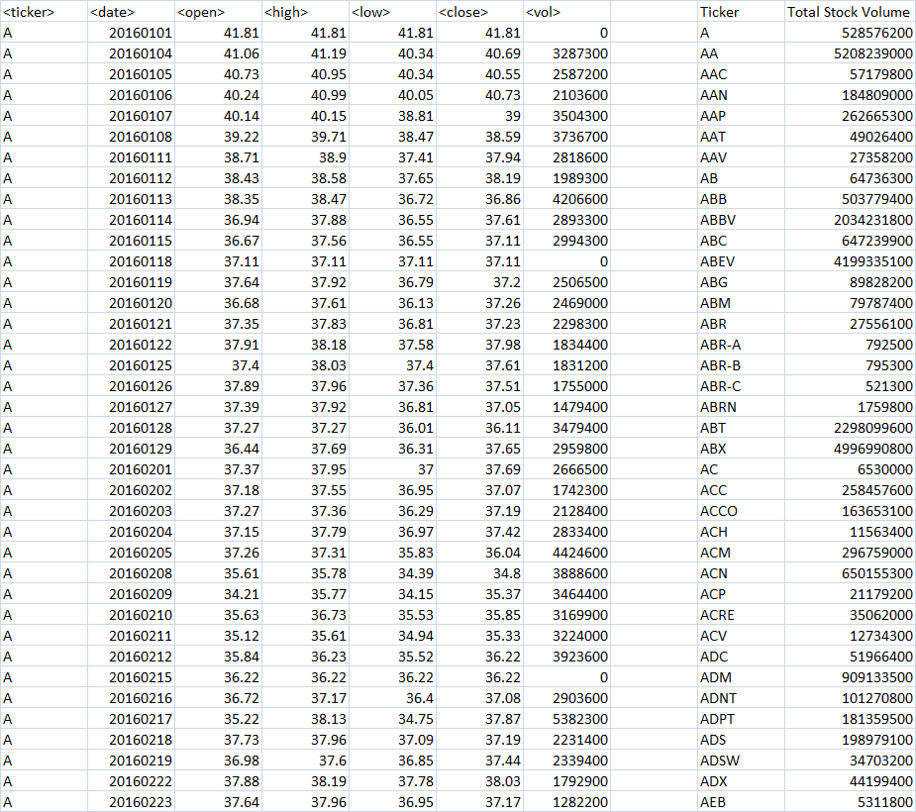

**2015 Summary**

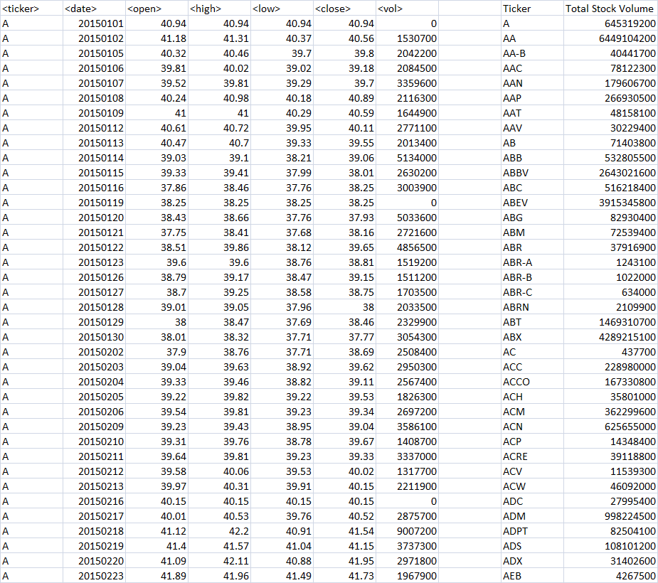

**2014 Summary**

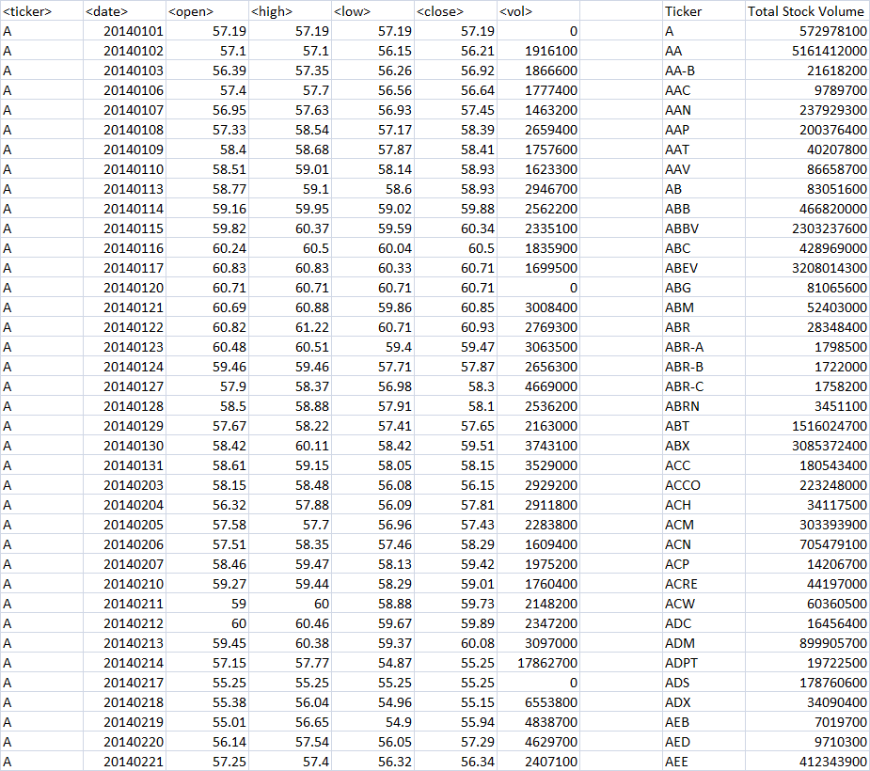

**VBA Code Snippet**

